Python

Assignment – I

By

Mouli S

Batch - 02

[moulisankar2002@outlook.com](mailto:moulisankar2002@outlook.com)

**Question - 01**

Using Python read the attached file in Python and print it’s output.

**Code:**

# Using Python read the attached file in Python and print it’s output.  
  
# importing the pandas  
import pandas as pd  
  
df = pd.read_csv('input_assign_learn_from_vinit.csv'**,** delimiter=',')  
  
print(df)

**Output:**

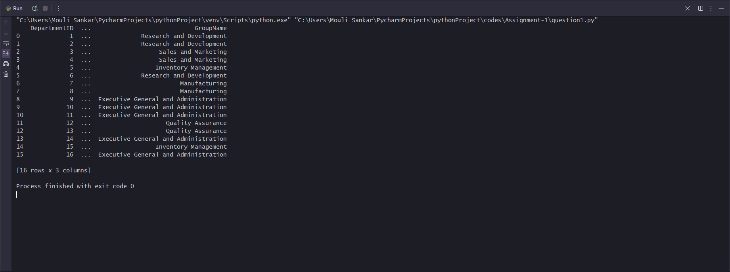

**Question - 02**

Load data in table (new) in SQL Server Database

**Code:**

# Load data in table (new) in SQL Server Database  
  
import pyodbc  
import pandas as pd  
  
# Connection to SQL Server Database  
conn_db = pyodbc.connect('Driver={SQL Server};'  
 'Server=Mouli-Sankar;'  
 'Database=Hexaware;'  
 'Trusted_Connection=yes;'  
 )  
  
cursor = conn_db.cursor()  
  
# Create Table having name as learn_python_batch03  
cursor.execute('''  
 create table [hexaware].[dbo].[input_assign_learn_from_vinit]  
 (  
 DepartmentID int,  
 Name varchar(100),  
 GroupName varchar(100)  
 )  
''')  
  
# Read text File  
df = pd.read_csv("input_assign_learn_from_vinit.csv"**,** delimiter=",")  
print("File has following data \n"**,** df)  
  
# Insert Values from Flat File to Database  
for row in df.itertuples():  
 cursor.execute('''  
 insert into [dbo].[input_assign_learn_from_vinit] (DepartmentID, Name, GroupName)  
 values(?,?,?)  
 '''**,** row.DepartmentID**,** row.Name**,** row.GroupName  
 )  
  
conn_db.commit()  
conn_db.close()

**Output:**

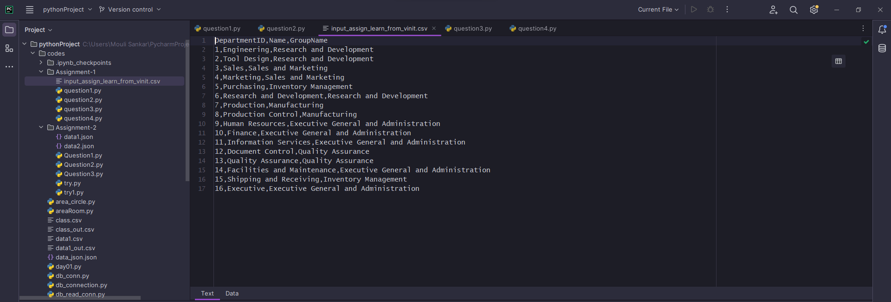

**Question – 03**

From the new table created in 2. please filter data for Group = ‘Research and Development’ and load into another table

**Code:**

import pandas as pd  
import pyodbc  
  
# db connection  
conn_db = pyodbc.connect('Driver={SQL Server};'  
 'Server=Mouli-Sankar;'  
 'Database=Hexaware;'  
 'Trusted_Connection=yes;'  
 )  
  
cursor = conn_db.cursor()  
  
query1 = ('''  
 SELECT *  
 FROM [Hexaware].[dbo].[input_assign_learn_from_vinit]  
 WHERE GroupName = 'Research and Development'  
 '''  
 )  
  
# load a data into dataframe  
df = pd.read_sql(query1**,** conn_db)  
  
# new database in sql server  
print(df)  
  
for row in df.itertuples():  
 cursor.execute('''  
 insert into [dbo].[input_assign_learn_from_vinit_R&D] (DepartmentID, Name, GroupName)  
 values(?,?,?)  
 '''**,** row.DepartmentID**,** row.Name**,** row.GroupName  
 )  
  
conn_db.commit()  
conn_db.close()

**Output:**

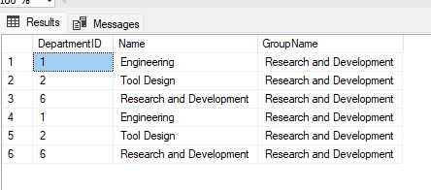

**Question – 04**

Python program should print content of table loaded in 3

**Code:**

# creating connection  
  
import pyodbc  
# import pandas as pd  
  
# Connection to SQL Server Database  
conn_db = pyodbc.connect('Driver={SQL Server};'  
 'Server=Mouli-Sankar;'  
 'Database=Hexaware;'  
 'Trusted_Connection=yes;'  
 )  
  
cursor = conn_db.cursor()  
  
# Create Table having name as learn_python_batch03  
df = cursor.execute('''  
 SELECT * FROM [hexaware].[dbo].[input_assign_learn_from_vinit_R&D]  
''')  
  
df = cursor.fetchall()  
  
for row in df:  
 print(row)

**Output:**

